giovanna troisi

Date of birth: 28/09/1996
Address: 00183, Rome
Email: giovanna.troisi@uniroma1.it

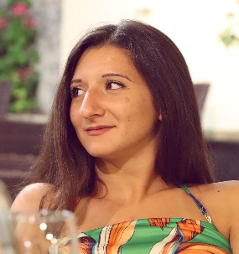
experiences

11/2022 – today
PhD PSYCHOLOGY AND COGNITIVE SCIENCES

universitY OF ROME “Sapienza”

09/2021 – 03/2022

TRAINEE IN CLINICAL PSYCHOLOGY (500 HOURS)

PSYCHODIAGNOSIS AND PSYCHOTHERAPY PRIVATE CENTER “klinikos”

03/2021 – 09/2021

TRAINEE IN GENERAL PSYCHOLOGY (500 HOURS)

universiTY OF ROME “sapienza”. department of dynamic and clinical psychology and health sciences

OTHER WORK EXPERIENCES

01/2022– 10/2022

SOCIAL OPERATOR

cooperativa sociale “hagape 2000”

2018/2022

activity tutor

onlus “il ponte 2008”
- 09/2021 – 06/2022: Lab of Scenography – “Viaggiatori nell’arte” project
- 01/2020 – 06/2021: Online lab “Ciao, sono io!”
- 09/2019 – 05/2020: Lab “Consapevolezza di sé” – I.S.O.L.A project
- 11/2018 – 06/2019: Lab of Theatre and Movement

education

09/2022

LICENSE TO PRACTICE AS psychologist

11/2020

master degree in clinical psychology (lm-51)

university of rome “sapienza”
Final mark: 110/110 cum laude (full marks with honors)

07/2018

bachelor degree in psychologic sciences and techniques (l-24)

university of chieti and pescara “gabriele d’annunzio”
Final mark: 103/110

07/2015

high school leaving qualification in classical studies

classical high school of salerno “torquato tasso”
Final mark: 100/100

publications and congresses

Forte, G., Troisi, G., Pazzaglia, M., Pascalis, V. D., & Casagrande, M. (2022). Heart rate variability and pain: a systematic review. Brain sciences, 12(2), 153.

10/2021 SIPF’s Congress (poster section): Troisi, G., Casagrande, M., Favieri, F., Forte, G. The role of cognitive inhibition in the autonomic responses to pain: an empirical study.

languages

ITALIAN: MOTHER TONGUE

INGLESE: fluent

SPAGNOLO: GOOD

