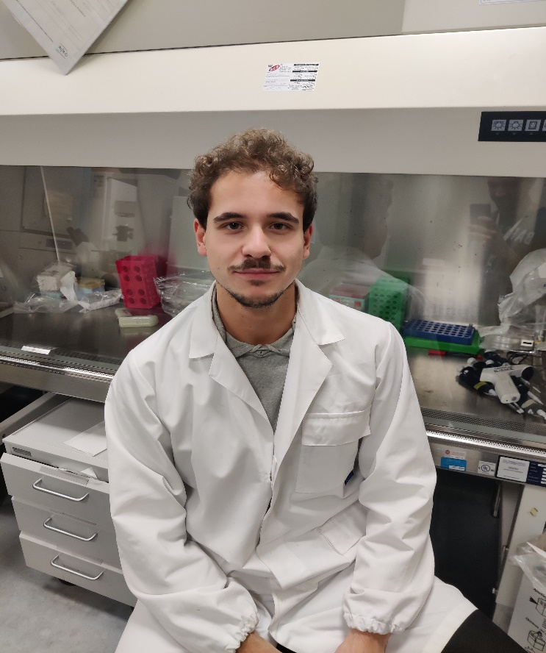

Curriculum Vitae

ADABBO GENNARO

# WORK EXPERIENCE

Dates (from-to):

Name and address of employer:

Type of business or sector:

# FROM 11/2022-ONGOING (END DATE 10/2025)

Sapienza University of Rome; Laboratory of Molecular Oncology, Department of Molecular Medicine, Viale Regina Elena 291, 00161, Rome, Italy

Molecular Oncology

Occupation or position held: Ph.D student in Molecular Medicine

Main activities and responsabilities: Cell biology and molecular biology

# EDUCATION

Dates (from-to): **FROM 11/2022-ONGOING (END DATE 10/2025)**

Name and type of organization providing education and training:

Sapienza University of Rome; Laboratory of Molecular Oncology, Department of Molecular Medicine

Occupation or position held: Ph.D. student in Molecular Medicine

Principal subjects/occupational skills covered:

The ongoing Ph.D. project, named “Defining the role of the

cytoskeleton regulator inverted formin 2 (INF2) in Hedgehog-dependent medulloblastoma” aims to study the INF2 function and cytoskeleton remodelling in hedgehog signaling pathway. In order to understand how INF2 function in controlling actin polymerization, microtubule dynamics and mitochondrial fission could impact on the regulation of hedgehog signaling, this project aims to analyze the cytoskeleton and mitochondria dynamics following modulation of INF2 expression in Hedgehog- dependent cells. The final aim of the project is to identify new effective therapeutic targets to for the treatment of medulloblastoma. We expect our efforts to pave the way to a novel area of investigation in HH signaling.

The project is being carried out with different models (cell lines, primary cells and mouse and human brain tissues) and techniques (cell biology, molecular biology).

This project is being carried out under the supervision of Prof. Lucia Di Marcotullio and Prof. Paola Infante, Sapienza University, in collaboration with Prof. Francesca Bartolini, Columbia University.

Dates (from-to): **FROM 10/2020-10/2022**

Name and type of organization providing education and training:

Principal subjects/occupational skills covered:

Sapienza University of Rome

cell biology, molecular biology

Master’s degree project named “The cytoskeleton in the regulation of Hedgehog signaling and in the Hedgehog-dependent medulloblastoma: study of the role of inverted formin 2, INF2”.

Immunoblot analysis, immunoprecipitation, in vivo ubiquitylation assay, cell proliferation assay, mRNA expression analysis, luciferase reporter assays, immunohistochemistry and in vitro wound healing assay were used on cell models.

Principal subjects: Biodiversity and Human evolution, Human Genetics, Clinical Molecular biology, Molecular Virology, Regulation of gene expression in eukaryotes, Molecular biology of stem cells, Epigenetic control of gene expression, Molecular oncology, Structure, biosynthesis and analysis of proteins, Parasitology,

Title of qualification awarded:

Master’s degree in Genetic and molecular biology (LM-6, D.M 2017), Vote 110/110 *summa cum laude*.

Dates (from-to): **FROM 09/2017-09/2020**

Name and type of organization providing education and training:

University of Sannio (BN, Italy)

Principal subjects/occupational skills covered: General competences on Cellular Biology, Chemistry, Physics,

Elements of law and economics,

Physics, Informatics, English,

Mathematics and statistics, Biochemistry, Histology,

Molecular biology, Chemical physics, Endocrinology,

Genetics Microbiology, Clinical biochemistry, Bioinformatics,

Industrial biotechnology, Pharmacology and toxicology, Physiology, Pathology.

Thesis project: “The functional deficiency of the BCS1L chaperone protein is the cause of the onset of GRACILE syndrome”.

Title of qualification awarded:

Bachelor’s degree in Biotechnology (L-2, D.M. 16/03/2007), Vote 110/110 *summa cum laude*

# TRAINING

Dates (from-to): **FROM 10/2020-10/2021**

Name and type of organization providing education and training:

Sapienza University of Rome, Laboratory of Molecular Oncology, Department of Molecular Medicine

Dates (from-to): **FROM 05/2020-07/2020**

Name and type of organization providing education and training:

University of Sannio, Laboratory of Biochemistry and Molecular Biology, Dept. of Science and Technology, University of Sannio, Benevento (Italy

# PERSONAL SKILLS AND COMPETENCES

Mother tongue: Italian

Other languages: English (IELTS, Europass Level B1)

Social skills and competences:

Good communication skills, acquired during the studies in Italy and good ability to work in team, in international groups and in multidisciplinary projects.

Organizational skills and competences:

Good organizational skills acquired during the studies in Italy and during my Ph.D. activity: good autonomy, ability to plan and organize projects. High predisposition to team work and multidisciplinary project organization. High flexibility and adaptability.

Technical skills and competences:

**Data analysis:** Adobe Photoshop, Image J, Image Lab, GraphPad. Use of various DataBases and tools: NCBI, PDB, BLAST, GenScript, OncoMX, Uniprot, Biorender, STRING.

**Cell culture:** Primary cells (murine medulloblastoma cells), immortalized murine and human cell lines.

**Immunofluorescence and histology:** Tissue preparation of histological samples: fixation, freezing, immunofluorescence. Cell preparation for immunofluorescence: fixation and permeabilization.

**Molecular Biology techniques:** Plasmidic and genomic DNA extraction, DNA mutagenesis, cloning, RNA extraction, reverse transcription, PCR, quantitative real time PCR, ubiquitination assays, gel electrophoresis, luciferase report assays.

**Analysis of proteins:** Protein extraction and western blot analysis, protein post-translational modifications analysis; *in vivo* and *in vitro* immunoprecipitation.

**Cellular biology:** DNA and siRNA transfection, cell treatments, BrdU and EDU assay, production and use of lentiviral vectors.

**Animal (scientific procedures):** manipulation of mice and mice’s brain tissues, tail cutting, toe clipping.