Education and Training:
PhD in English Literatures, Language and Translation
2023 – ongoing
Sapienza University – Rome
Master in Publishing – 2022
Scuola del libro – Rome
M.A. in Linguistics, Literatures and Translation
cum laude – 2022
Dissertation: Autotraduzione ed esofonia – Due fronti del translinguismo post-romantico
Sapienza University – Rome
M.Phil. in Literary Translation
Second Class Honours First Division – 2018
Dissertation: Tydinges of Translation – A Polysystem Study of the Italian Reception of Chaucer in the years 1970 – 2000
Trinity College University – Dublin
B.A. in Cultures, Literatures and Translation
cum laude – 2016
Dissertation: L’aristotelismo in Cina attraverso le opere di Francisco Furtado S. J. (1589 – 1653)
Sapienza University – Rome
Universidade Nova – Lisbon
Taiwan Normal University – Taipei

Languages:
English – C2
Cambridge Proficiency Qualification
Portuguese – C1
Completion of a postgraduate course
German – B2
Goethe-Zertifikat
Chinese – A2
Mandarin Training Center Certificate

Giulia Travaglini

Contacts:

Room 205
Viale dello Scalo S. Lorenzo 82, 00159 Rome (Italy)
+39 334 807 43 20
giulia.travaglini@uniroma1.it

Academic Interests:

Literary Multilingualism
Self-translation
Literary Field
Semiotic Theories of Translation
Complexity Thinking in Translation Studies

Working Experience:
Literary Agency Internship – 2022/3
Pietrosanti Agenzia Letteraria
Effetto Strega Podcast Writing and Interviews – 2022
Scuola del libro and Bellonci Foundation
Safarà Editore Sales Assistant – 2022
Turin International Book Fair
Eirenefest Book Fair Logistics – since 2021
Eirenefest – Peace and Nonviolence Book Fair
Transcriptionist – since 2020
Appen Limited
Italian > English Translator – since 2020
Energia per i diritti umani ONLUS
Union of Italian Translators STRADE Hostess – 2019
Milan Book Pride and Bologna Children’s Book Fair
Guide and Interpreter – 2015
Tuvalu National Pavilion – Venice Biennale
English Tutor – since 2014
Italian and foreign adults and school students

Computer Skills:
AegiSub, Calibre, Facebook, Google Meet, Microsoft Office, SDL Trados, WordPress, Zoom.

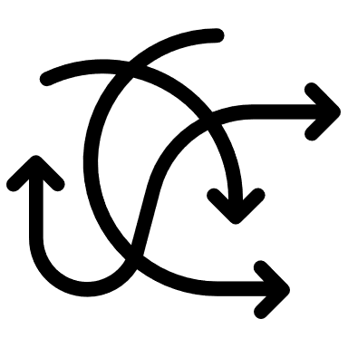 Volunteering Experience:
Women’s Entrepreneurial Projects (logistics support) since 2020
Équipe Keur Marietou – Energia per i diritti umani ONLUS
Rome and Dakar

Giulia Travaglini

Personal skills:

Intercultural fluency
Flexibility
Growth mindset
Problem solving
Teamwork

