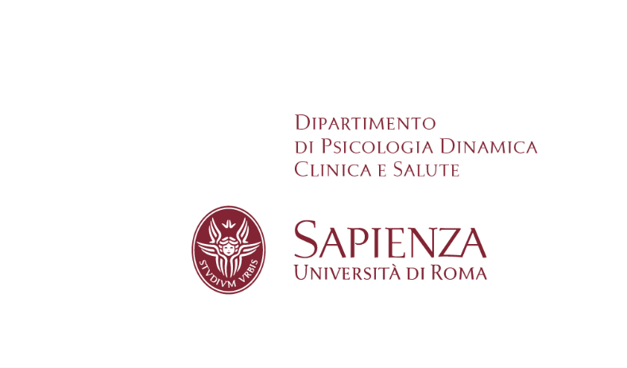

Oleksandra Khalaim, Ph.D.

Researcher at Swedesd
Sustainability Learning and Research Centre,
Department of Women's and Children's Health,
Uppsala University, Sweden

Visiting Professor at Sapienza-
University of Rome

“Balancing the Climate and Mental Health Threats:
Climate-anxiety Identification in Higher Education Institutions”

26 Maggio 2023 – ore 11 - 13
Aula Magna Dipartimento Psicologia Dinamica, Clinica e Salute

The research aims to map climate anxiety for both teachers and students in sustainability-related fields at Uppsala University with a specific focus on the campus Gotland. The research includes the mapping of perceptions, personal experience, and attitudes that students and lecturers in sustainability-related fields at Uppsala University (campus Gotland) have towards climate anxiety as well as an analysis of climate anxiety related actions and work of the Student Health Service at Uppsala University (campus Gotland) and other Swedish universities.

Per informazioni scrivere una mail a carlo.lai@uniroma1.it

