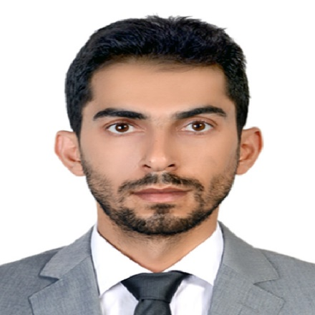
PERSONAL DETAILS: YOUNES AGHAPOUR SABBAGH
Residential Address: Rome, Italy
Mobile: +393755491737
Date of Birth: 8 July 1986
Nationality: Iranian
E-Mail: younes.aghapour@uniroma1.it
CAREER OBJECTIVE
To expand skills and experience
EDUCATION HISTORY
2019-Onwards University of Sapienza, Rome, Italy
Ph.D. Candidate in Comparative Uniform Commercial Contracts
2017 - 2019 University of Sapienza Rome, Italy
LLM in European Studies grade achieved is 110/110 with honors

2013 – 2016 University of Tehran, Tehran, Iran
Master in International Trade law
2005 – 2010 University of Tabriz, Tabriz, Iran
Bachelor of Law
Scientific/Work /Sport EXPERIENCE

Jan 2005 – 2010  2006-2019  2007-Onwards  2018-Onwards | Iranian Elites Center, Tehran and Tabriz  Responsibilities and achievements:  - Member of Iranian elites  - Consultant of chamber  - Vice president  - Secretary of Intellectual Property Right office  Conference and Seminars  - Workshop on IP and Patent right  - Workshop on IP and Army Security Patent right  - Conference on feasibility of joining Iran to WTO  - International comparative law seminar  - IP seminar (University of Tabriz)  - Conference on International Trade law (commercial chamber of Tabriz)  - ...  Articles  - IP in Iranian legal system  - Patent registry  - Legal aspects of Military patent registry  - Iranian oil and Gas contracts  - BOT and BOOT contracts  - Legal aspects of Iranian technology transfer contracts in Energy industry  - technology transfer Contracts  - Sport Contract  - An Analysis of Multinational Corporations Contracts  - Comparative analysis of Invalidity of Contracts under Western system and Iranian civil law  other work majors  - Research  - Researcher in The International Institute for the Unification of Private Law (UNIDROIT)  Research fields  - International Commercial Contracts  - Intellectual Property  - International Commercial Arbitration  - Technology Transfer contracts  - Islamic Banking Law  - Sport Contracts

OTHER SKILLS AND CERTIFICATES

Computer Skills:
- Microsoft applications (Word, Excel, Office, PowerPoint, Outlook, Access) – Advanced
- Microsoft Office Document Imaging and Scanning - Advanced
- Acrobat Reader 6.0 – Intermediate
- Photoshop – Intermediate
- Latex- Intermediate

Language Skills:
- Azeri - mother Tongue
- Persian- Native language
- Turkish-advanced
- English – advanced
- Arabic-basic
- Italiano Basic

PERSONAL COMPETENCIES

- Adoptable manner
- Excellent oral and written correspondence with an exceptional attention to detail
- Highly organised with a creative flair for project work
- Enthusiastic self-starter who contributes well to the team

INTERESTS AND ACTIVITIES

- Researching, studying, sports, traveling

