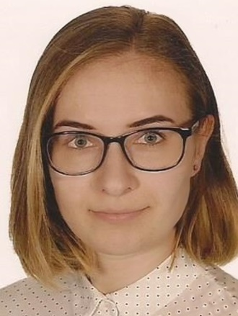
Joanna Ryszka
Current location: Katowice
Telephone: +48 513 055 917
E-mail: joanna.ryszka@us.edu.pl
Date of birth: 29/09/1996
PROFESSIONAL EXPERIENCE
10.2021 – present a lecturer (Employer: University of Silesia, Katowice)
03.2021 – present an English teacher (Employer: Wyższa Szkoła Humanitas, Sosnowiec)
10.2019 – 11.2019 an intern (Employer: Translation Agency “Euro Alphabet”, Lublin)
07.2019 – 09.2019 a Problem Management Intern (Employer: “Capgemini”, Katowice)
03.2018 – 09.2018 a café employee (Employer: Café “Co Bądź”, Tychy)
06.2018 – 07.2018 an intern (Employer: Insurance agency “B.F.H.”, Tychy)
07.2015 – 04.2016 a waitress / a barmaid (Employer: Café “Cynamon”, Tychy)
08.2014 – 09.2014 an intern (Employer: Autocenter Koch GmbH, Berlin, GERMANY)
EDUCATION
2020 – present PhD STUDENT IN LINGUISTICS
University of Silesia in Katowice and Sapienza University in Rome
Thesis: The Impact of British-Japanese Relations on British English: a Diachronic Sociolinguistic Study
2018 – 2020 MASTER’S DEGREE IN ENGLISH PHILOLOGY (specialization: Translation Programme with Japanese)
University of Silesia in Katowice
Graduation thesis: The Selective Analysis of Japanese and English Compounds in Terms of Semantic Transparency and Analysability
2015 – 2018 BACHELOR’S DEGREE IN ENGLISH PHILOLOGY (specialization: Translation Programme with Japanese)
University of Silesia in Katowice
Graduation thesis: The Linguistic analysis of English borrowings in Japanese

LANGUAGES
Polish: Mother tongue
English: C2
Japanese: N2
German: A2
French: A1
Chinese: HSK1
OTHER SKILLS
Microsoft Office: Word, Excel, Power Point (advanced)
Programming languages: Python (basic), R (basic)
Teaching skills, artistic skills, cooperative, and good communication
CERTIFICATE
2020 – Certification of Completion of The Basic Python Programming Course

