Dottorato di Ricerca in Ingegneria Elettrica, dei Materiali e delle Nanotecnologie
Relazione annuale A.A.:
2021/2022
Ciclo di Dottorato:  XXXVII | Curriculum:  A
Dottorando/a:  Naseer Ahmad | Supervisore:  Prof. Fabio Giulii Capponi

TITOLO DELLA RICERCA: …
Multiphysics Design of Axial Flux Permanent Magnet Synchronous Electric Machines at High Power Densities and Rotational Speeds
- Sintesi dell’attività di ricerca svolta
The increasing demand for energy and environmental concerns have driven researchers to find cheap and environment-friendly solutions. Demands toward private vehicles have been increased in the past decade, which leads to global CO₂ emissions. The researcher proposed a solution of electric and hybrid vehicles, as result, the automobile industry is requiring for electric machines manufacturers to ever increase the power density, to have lightweight, more compact, high-power density, less expensive powertrains, higher electric, and magnetic loadings. The drive for higher power density, with the machine performances approaching their limits, produces the effect that the electromagnetic, magnetic saturation effect, electric and magnetic loading, thermal and mechanical designs are becoming tightly interconnected. The existing design high power density electric machines have thermal, and mechanical constrains. Instead, when trying to maximize power density, there are only few possible solutions that meet both the required performance and the actual limitations, with the thermal and mechanical constraints playing a big role in the overall feasibility of the design. In these cases, the electric machine design becomes an important Multiphysics problem, where the all the aspects need to be addressed together.
For thermal concept, an introduction to the study of heat transfer. The three modes of heat transfer (conduction, convection, and radiation), the first two modes are appeared more dominant in many practical fields. However, radiation is most important mode of heat transfer at high temperatures. The heat transfer governing the partial differential equation for conduction within a body. The heat conduction equation in the form of rectangular, cylindrical, and spherical coordinate systems and the boundary and initial condition equations that are used in conjunction with the heat conduction equation to determine the temperature distribution in the body.
  - Conduction
In a solid, the flow of heat by conduction is the result of the transfer of vibrations energy from one molecule to another, and in fluids it occurs in addition because of the transfer of kinetic energy. Heat transfer by conduction may also arise from the movement of free electrons, a process which is particularly important with metals and accounts for their high thermal conductivity.
Fourier’s law is an empirical law [1] derived from experimental evidence and observation. According to Fourier’s law consider the steady-state conduction experiment and A cylindrical rod of known material is insulated on its lateral surface, while its end faces are maintained at different temperatures, with T1>T2 as represented in Figure 1. Fourier’s law states that the rate of heat flux, $\dot{q }$, through a uniform material is directly proportional to the area of heat transfer and to the temperature difference, ΔT, in the direction of heat flux, and is inversely proportional to the length of the path flow, Δx. Thus, Fourier’s law allows the calculation of heat fluxes for a given temperature fi eld. Temperatures are calculated from the principle of energy conservation.
Where, qx (heat transfer) depends on: ΔT the temperature difference, Δx the length of rod, and A the cross-section area.
$q_{x} =-kA \frac{dT}{dx}$ (1)
Where $q_{x}$is the heat rate (W), k is the thermal conductivity of material and K physical property, a characteristic of the materials, which measures how fast heat flows in the materials and SI unit is (W/m.K). The minus sign is because heat transferred in the direction of decreasing temperature.
According to energy conservation law:
$E_{in }+ E_{g}-E_{out}= E_{st}$ (2)
$E_{in }$is energy enter, $E_{g}$ is energy generation, $E_{out}$ is energy out, and $E_{st}$ is energy stored.
Rearranging
$\frac{∂}{∂x}\left(k\frac{∂T}{∂x}\right)$ + $\frac{∂}{∂y}\left(k\frac{∂T}{∂y}\right)$ + $\frac{∂}{∂z}\left(k\frac{∂T}{∂z}\right)+ \dot{q}=ρc_{p }\frac{∂T}{∂t}$ (3)
Equation (3) is called heat diffusion equation.
We develop a mathematical model for three different types of solid block as shown in Figure 2. Consider first block is copper with thermal conductivity k1 and width L1. The uniform heat generated in copper block and transmitted to all other blocks. The second block for insulation specially paper with thermal conductivity of k2. The last is iron block with thermal conductivity k3 and with thickness L3, as shown in Figure 3.
T(x) = $-\frac{\dot{q}}{k_{3}}L_{1}$x $\text{–} \frac{\dot{q}}{k_{2}}L_{1} L_{2} - \frac{\dot{q}}{2k_{1}}L_{1}^{2}\text{+}{ T}_{1}$ (4)
T($L_{3}$) = $-\frac{\dot{q}}{k_{3}}L_{1} L_{3}$ $\text{- }\frac{\dot{q}}{k_{2}}L_{1} L_{2} - \frac{\dot{q}}{2k_{1}}L_{1}^{2}\text{+}{ T}_{1}$ (5 )
Figure 3 and 4 represents the finite element analysis in three different blocks and Figure 5 illustrate mathematical representation in copper block and insulation block. This mathematical modelling verified through FEA and results verified 100 percent.
  - 2D mathematical modelling of conduction
We considered one-dimensional heat conduction and assumed heat conduction in other direction is negligible. Many heat transfer problems encountered in practice can be approximately as being one-dimensional, but this is not always the case. Sometimes we need to consider heat transfer in other directions as well when the variation of temperature in other direction is significant. We formulated and solution of two-dimensional steady heat conduction in rectangular coordinated using differential equation method. The two-dimensional heat transfer as shown in Figure 6. Applying different boundary condition and formulated final equation.
$$θ\left(x,y\right)= \frac{2}{π} \sum_{n=1}^{∞}{\frac{{(-1)}^{n+1}}{n}}\sin{\frac{nπx}{L} \frac{Sinh (\frac{nπy}{L})}{Sinh (\frac{nπW}{L})} } (6)$$
  - Convection
Convection is the sum of both the random molecule movement and interaction between each other, which is called diffusion, but also the bulk movement or the fluid movement on a macroscopic level. The later mechanism is called advection. Convection between a fluid over a surface is a common situation in engineering applications and an example is a radiator. Besides improving winding techniques and material thermal properties, forced cooling is also commonly used in highly loaded electrical machines to improve their heat transfer performances [2, 3].
We take case study as shown in Figure 7 with initial boundary conditions and this case study was verified through Simcenter MAGNET Thermal 2021.2 software and the result was 100 percent same.
  - Extended Surfaces and Fins
Consider a surface area exchanging heat to the environment by convection process. The rate of heat transfer ($\dot{Q)}$, is according to newton law of cooling.
$$\dot{Q}=hA_{s}\left(T_{s}- T_{∞}\right) (7)$$
Where, $h$ = convective heat transfer coefficient ($\frac{W}{m^{2}}.k)$, $A_{s}$ = outer surface area, $T_{s}$ = surface temperature, and $T_{∞}$ = ambient temperature.
We work on different sizing equation of fins with pre-defined heat source as shown in Figure 8 and this problem was simulated with Thermnet software and results near to mathematical results.
List of Activities Carried Out:
- Develop 1D and 2D mathematical model for conduction and verified through FEA
- Develop a mathematical modelling of convocation (force and natural convection) and natural convection verified has also been using FEA
- Analyze sizing of extended surfaces and fins
References:
[1] Bergman, Theodore L., Theodore L. Bergman, Frank P. Incropera, David P. Dewitt, and Adrienne S. Lavine. Fundamentals of heat and mass transfer. John Wiley & Sons, 2011.
[2] Zhe Huang, Shafigh Nategh, Mats Alaküla, Viktor Kassila, Jinliang Yuan, “Direct Oil Cooling of Traction Motors in Hybrid Drives”, IEEE International Electric Vehicle Conference (IEVC), Greenville, SC, 2012.
[3] Zhe Huang, Francisco Marquez, Mats Alaküla, Jinliang Yuan, “Characterization and Application of Forced Cooling Channels for Traction Motors in HEVs”, XXth International Conference on Electrical Machines (ICEM), Marseille, 2-5 September 2012.
- Seminari, Corsi, Workshop e Scuole
ECE 511, Theory and Control of Synchronous Machines by D. Novotny (3CFU)
ECE 713, Electric Machine Design by T. Lipo (3CFU)
Dynamics of Electrical Machines and Drives by Prof. Fabio Giulii Capponi (6CHF)
Self-Study:
Book: Introduction to heat and mass transfer by FRANK P. INCROPERA
- Periodi trascorsi all’estero
- Partecipazione a Congressi Nazionali e Internazionali
- Pubblicazioni su atti di convegno (prodotte o in corso di pubblicazione)
- Pubblicazioni su riviste (prodotte o in corso di pubblicazione)

(formato word, max 10 pagine; si prega di inserire eventuali figure e tabelle in un’apposita sezione “Allegati” in fondo al documento)
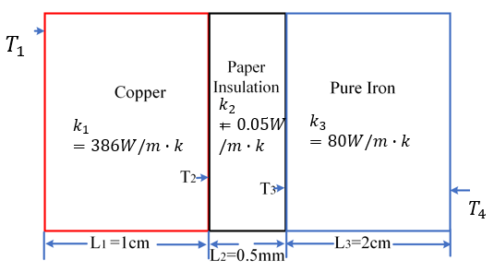
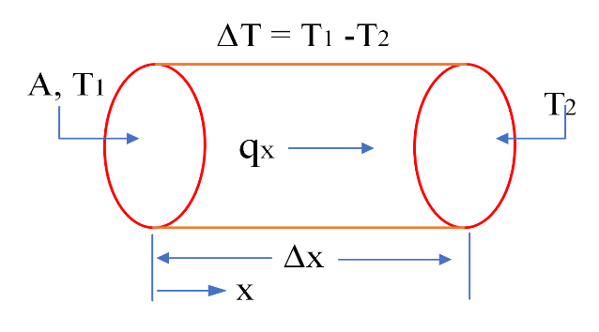
Allegati (Figure e tabelle)
Figure 1. Fourier law of heat conduction Figure 2. Heat conduction in three different blocks
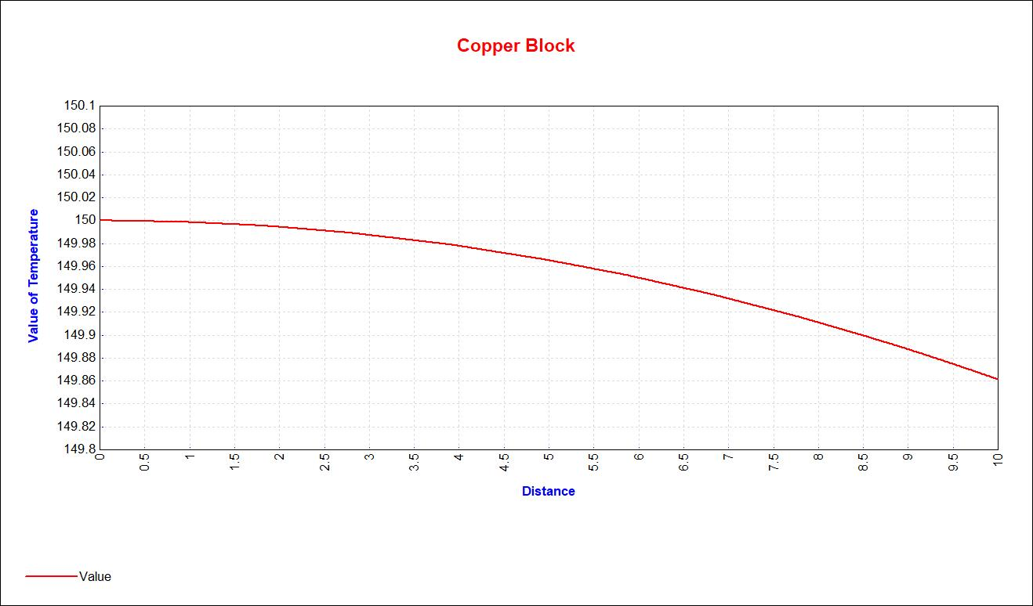
Figure 3: Temperature distribution in copper block with FEA
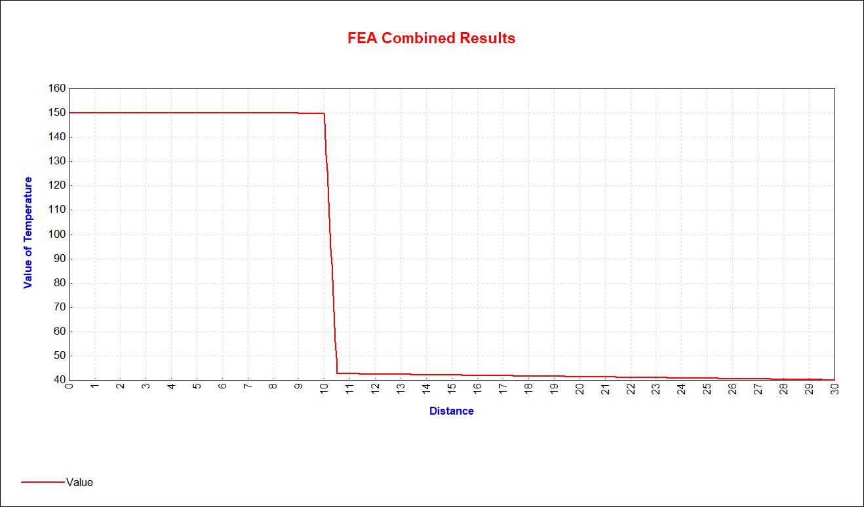

Figure 4: Temperature distribution in all blocks with FEA
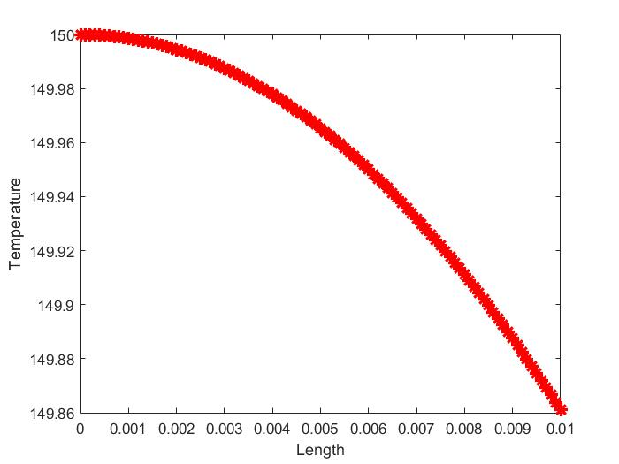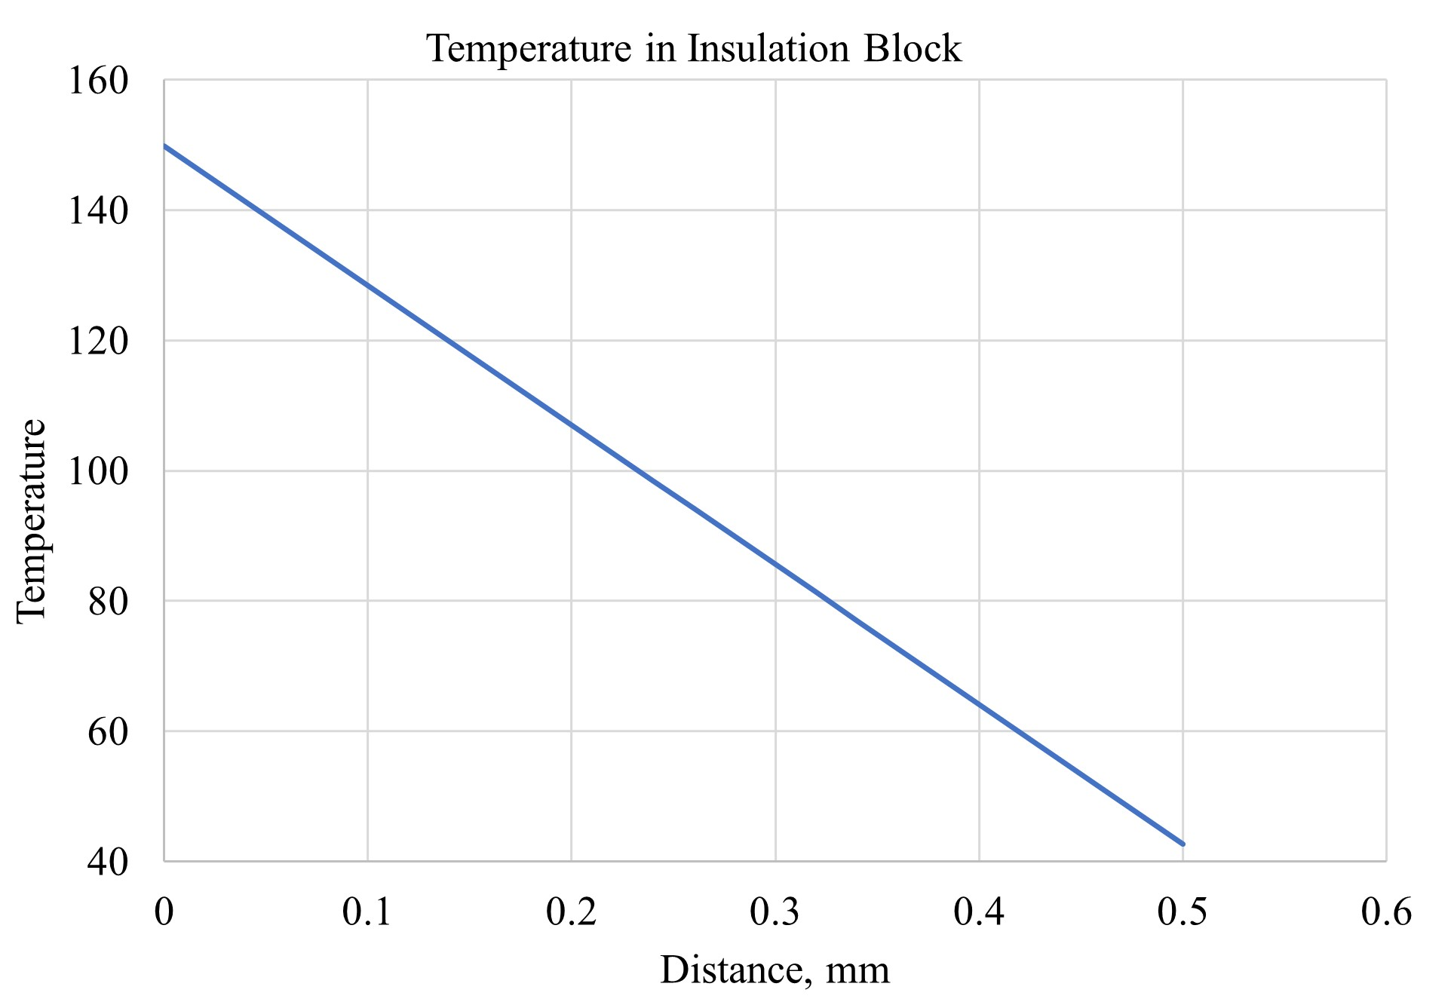
- (b)
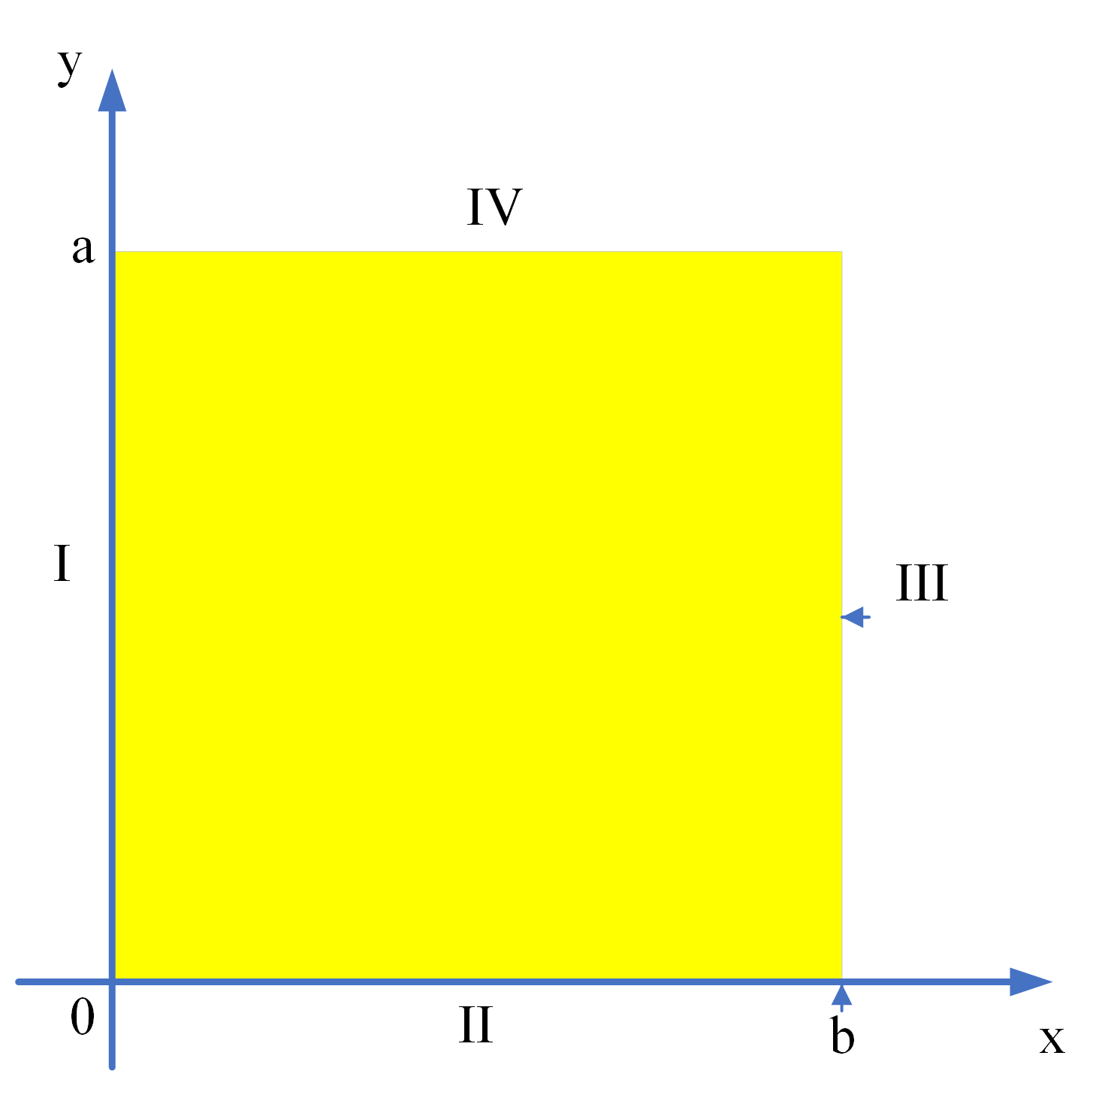
Figure 5 (a): Temperature distribution in copper block with mathematical modelling (b)Temperature distribution in insulation with mathematical modelling
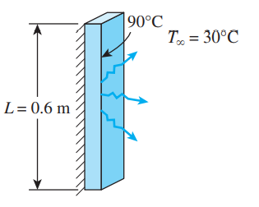

Figure 6: Two-dimensional heat conduction Figure 7: Thin square for natural convection
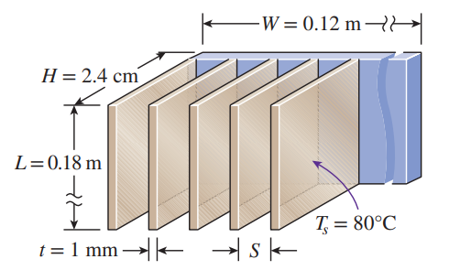
Figure 8. Schematic view of fins

