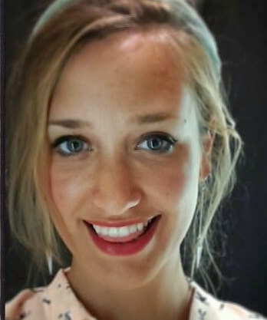
Lennie Dupont

education and certificates
Maastricht University, the Netherlands September 2017 – August 2018
Master of Psychology: Cognitive Neuroscience
cum laude
University of Antwerp, Belgium September 2013 – August 2016
Research Master of Biology: Evolution and Behaviour
cum laude
Bachelor of Science, Biology September 2010 – August 2013

Other certificates:
- MRI safety training certificate
- ‘Laboratory Animal Science for Scientists cat. C’ certificate (FELASA accredited)
- Online Linguistic Language Support: twice C2 level (English) according to CEFR
- IELTS English language certificate: C1 level

RESEARCH EXPERIENCE
Maastricht University, The Netherlands January – August 2018
Master Thesis Research Internship: The role of race and proximity in a freeze-like defence mechanism to aversive stimuli in Virtual Reality: combination of a behavioural study using body sway platform and electrocardiography and a fMRI study using a 3T-scanner getting proficient in analysing neuroscientific data using the 3T fMRI-scanner, VR tools, EEGLAB, AMTI force platform, EGI, Net station, BrainVoyager, Python and Matlab.
Aristotle University of Thessaloniki, Greece September 2015 – July 2016
Research Master Thesis Research Project:
Seasonal analyses of the effect of sea water temperatures on the physiological condition of two farmed fish species, within the framework of climate change learned how to plan and structure a full research independently and successfully finish it.
University of Antwerp, Belgium September 2014 – June 2015
Individual Research project: the assessment of objective welfare indicators on the Green anole in captivity my statistical skills increased significantly and I learned a wide variety of new laboratory techniques
PhD support work: September 2014 – June 2016
Transcribing and translating interviews from Dutch to English for a PhD project
An assignment requiring scientific levels of accuracy and punctuality
Sokoine University of Agriculture in Morogoro, Tanzania July – August 2012
Bachelor thesis: Tropical internship: the incidence and quantification of bipedal locomotion of the wild vervet monkey or Chlorocebus pygerythru
improved my presentational skills and my competence of working in a team

Skills:
Languages Dutch (native language), English (C2 level), French (B2 level), Italian (B1), Greek (A2 level), German (A1)
Software Proficient in MS Office, R., Rstudio, Matlab, EEGLAB, BrainVoyager, SPSS, Net Station, ArcGIS, Jwatcher (Java), RAD video tools, ImageJ, Vortex & Stella (MS Excel), Sigmaplot, Express Scribe, Aegisub, Mendeley
Statistics Thorough knowledge on statistical modelling and skilful in data analyses
Teamwork I am a natural team player, within both academic and non-academic environments
International experience
Through research projects abroad I learned to adapt to a range of different group dynamics, laboratory techniques and cultures
Communication My oral communication and listening skills, as well as other social skills, developed throughout my studies and travels, meeting and socialising with a substantial variety of people

previous jobs & VOLUNTEER WORK
Currently:
PhD candidate in Social, Cognitive and Affective Neuroscience November 2019 -
in the AgliotiLab at La Sapienza, Rome
Neuroscience Article Writer for Maze engineers (freelance) April 2019 -
Full-time jobs:
Sales assistant for Meubles Furniture in Galway, Ireland October – December 2018
Collection officer for Ferratum Bank (PACTUM) in Moabit, Berlin June – August 2017
Content manager for Arvato Bertelsmann in Siemensstadt, Berlin March – June 2017
Student jobs:
Student Coach: 2014 - 2015
Private teaching to students of all grades (including higher education) for following subjects: chemistry, physics, mathematics, biology and study methods
Voluntary projects:
Workaway: Olive picking and organic farming in Samothrace, Greece 2016
SCI: Restoration of damaged grasslands in Evora, Portugal 2013

Hobbies
Philosophy: reading and listening, TED/TED-ED and TEDx Talks, Yoga and meditation, Nutrition, Travelling, Drawing, Plant-based cooking

