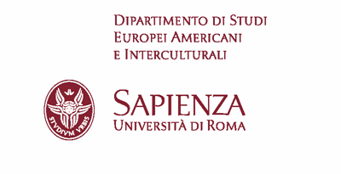

Ricerche slavistiche. New series. Monographic issue 2023 call for papers

STRANI LEGAMI/STRANGE CONNECTIONS
About the coexistence of languages ​​and cultures in Central Europe
Guest editors: Annalisa Cosentino (Sapienza University of Rome), Libuše Heczková (Charles University, Prague)

The long coexistence of cultures, particularly of Slavic and Germanic languages and cultures, in Central Europe has certainly been fruitful and full of positive interference, and not only conflictual. In this context it may be interesting to identify some relationships that go beyond the habit, the "strange connections":
- non-canonical methods of artistic creation and communication between different ethnic groups and cultures in Central Europe;
- unusual interactions between different religions and confessions, Reformations and Counter-Reformations in literary and philosophical works;
- erasing and deformation of memory caused by mechanisms of exclusion, by different ideologies, by gender determination;
- extraordinary individual destinies and acts, also with respect to particularly watchful illiberal regimes;
- “strange connections” among Germanic and Slavic languages ​​and cultures and non-Germanic and non-Slavic languages and cultures, in Central Europe;
- “strange connections” among languages in Central Europe.

Proposals (no more than 350 words) can be sent to ricercheslavistiche.seai@uniroma1.it, annalisa.cosentino@uniroma1.it, libuse.heczkova@ff.cuni.cz by 30 July 2022. Papers accepted for publication, written in Italian or in English, must be submitted by 1 Jan 2023; each paper cannot exceed 45,000 characters, including spaces.

